American Bar Association

Section of Public Utility, Communications
and Transportation Law

Report of the
INTERNET INDUSTRY COMMITTEE

2006 Fall Council Meeting

Chair:

Jonathan B. Wilson

Vice-Chair:

C. Celeste Creswell

Contributors:

Jonathan B. Wilson

C. Celeste Creswell

Joseph W. Ozmer, II

©2006 American Bar Association of Public Utility, Communications & Transportation Law.

Table of Contents

I. Internet Fraud Legislation 1

II. Update on the Communications Decency Act 8

PART I Internet fraud legislation

In response to a number of highly-publicized identity theft incidents, lawmakers have begun considering new legislation to address the problem of identity theft and of online fraud in general. In its Spring Report, the Internet Industry Committee looked at the large body of new state laws involving the mandatory disclosure of breaches in information security. Those laws attempt to address the problem of identity theft by obligating businesses that maintain online databases to notify the public when they believe their databases have been compromised.
In this Report, the Committee looks at other forms of legislation intended to prevent identity theft.

Types of Internet Fraud

To understand the scope of legislative responses, it is helpful to understand the types of Internet fraud prevailing today. Most Internet fraud, at least in terms of the volume of traffic and damage generated, springs from the attempt by perpetrators to engage in identity theft. By obtaining the name and other personally-identifiable information (“PIN”) of a real person, the perpetrator uses that information to extract cash from the victim’s account, to purchase goods with the victim’s funds (with the perpetrator either using the goods, exchanging them for a cash refund or reselling the goods for cash) or simply to damage the victim (whether for pure malice or for ideological reasons). Legislative attempts to fight identity theft vary in part by the approach they take to the various methods used by perpetrators to engage in identity theft.
Perpetrators of Internet fraud use a variety of methods to obtain PIN from potential victims, including:
      - Hacking into online databases that store PIN;
      - “Phishing” for PIN (“phishing” describes any scam whereby the perpetrator pretends to be a legitimate service provider that is asking the victim to provide PIN for an ostensibly appropriate purpose); and
      - Malicious code intended to copy or extract PIN from the computers of victims.
Of these three types of fraud, phishing and malicious code attacks seems to be the types of fraud that represent the greatest threats to Internet users at the current time, according to a recent report issued by Internet security vendor Symantec.
Malicious code attacks consist primarily of software programs that are unleashed by perpetrators onto the Internet, either through websites or through unsolicited email or spam. For example, a perpetrator might create a seemingly-innocent website, but include malicious code on the website that installs itself onto every computer that visits the site. Similar exploits may also sometime be distributed by e-mail. Often, the perpetrator hides the malicious code inside of a game or other interesting item that tempts the user to click on it. By clicking, the user activates the malicious code.
Malicious code comes in many varieties but most are either (a) “Trojan horses” that are intended to copy data (usually PIN) from a victim’s computer and then transmit the data back to the perpetrator or (b) “worms” that use the victim’s computer either to perpetuate the worm (i.e, sending further copies to other victims) or to launch other malicious code against other victims (turning the first victim’s computer into a “zombie” that acts on the commands of the perpetrator). In many cases, the perpetrator uses the malicious code to copy sensitive information from the victim’s computer or to copy the user’s key strokes, thereby obtaining sensitive information from the user when the user logs onto financial websites and the like. The Symantec 2006 Internet Threat Report indicated that worms made up 75% of the volume of the top 50 malicious code reports encountered in the first half of 2006 and that half of the top ten new malicious code types included Trojan horse programs.
Phishing scams are especially insidious. The perpetrator will either create a website that appears to represent the actual website of a real service provider or will distribute e-mail to victims that purports to originate from a legitimate service provider. To make the ruse realistic, the perpetrator will usually copy trademarked logos, color schemes, graphics and other trade dress to make the communication look authentic.
Compare, for example, the phishing e-mails found in Exhibits A and B (which masquerade as e-mails coming from SunTrust Bank) with the actual website for SunTrust Bank in Exhibit C. The fraudulent e-mails contain the SunTrust logo, using fonts and colors consistent with the SunTrust website, contain actual SunTrust 800 numbers for recipients to call and include a purported signature block that looks like the kind of signature a bank might send. Many Internet users can be fooled by trickery of this kind.

Georgia’s Anti-Phishing Bill

Several state legislatures are considering bills intended to reduce this kind of fraud. One example is Georgia Senate Bill 394, which was introduced in the Georgia Senate during the last session and is expected to be re-introduced in 2006. Georgia S.B. 394 provides, in pertinent part:

It shall be unlawful for any person, by means of a Web page, electronic mail message, or otherwise through use of the Internet, to solicit, request, or take any action to induce another person to provide identifying information by representing himself, herself, or itself to be a business without the authority or approval of such business.

The bill continues by creating a number of creative enforcement mechanisms. First, in additional to authorizing the Georgia Attorney General to bring civil enforcement actions against violators, the bill also creates a private right of action on behalf of any person “adversely affected by a violation” of the law. What makes this private right of action especially creative is that the bill contemplates a civil money remedy equal to “the greater of actual damages or $500,000” with the further potential for treble damages if “the defendant has engaged in a pattern and practice” in violation of the bill. The same provision authorizes the court to award a prevailing plaintiff its costs and reasonable attorneys’ fees.
Presumably, Georgia S.B. 394’s enforcement mechanism is intended to overcome what has been one of the prevailing problems in fighting Internet fraud. Governmental enforcement agencies are often outmatched when it comes to identifying and tracking down Internet fraud, especially when perpetrators often use technical means to hide their identifies. In an age when law enforcement must cope with high profile and high impact crimes, including violent crimes and terrorist threats, law enforcement is often unable to justify the high expense of pursuing Internet scam artists (whose impacts are usually felt in relatively small doses by individual victims).
Empowering private individuals (including the ISPs whose networks are often adversely affected by Internet fraud), the legislation puts an enforcement tool in the hands of private industry and then gives potential plaintiffs a financial “bounty” for pursuing Internet wrongdoers.
Georgia S.B. 394 shows signs of having been authored by an industry-friendly draftsman, however, as the bill contains a number of safe harbors intended to shelter legitimate enterprises from the potential for frivolous litigation. In particular, the bill provides that (a) employers will not be liable for the fraudulent acts of their employees (using the employer’s equipment or network) so long as the illegal acts were “without the employer’s knowledge, consent or approval”, (b) no person will be liable for illegal acts conducted on his computer if such acts were committed without that person’s “knowledge, consent or approval” and (c) no manufacturer or retailer of computer equipment will be liable for wrongdoing done with equipment sold by that person “to the extent that the manufacturer or retailer is providing third-party branded software that is installed on the computer equipment that the manufacturer or retailer is manufacturing or selling.”
Ohio’s Anti-Phishing Bill
Some legislators in Ohio are taking a slightly different approach while also trying to combat phishing and other Internet fraud. Ohio H.B. 633 defines “phishing” as:
“The use of electronic mail or other means for the purpose of committing theft or fraud by imitating a legitimate company or business in order to entice an authorized user to divulge passwords, credit card numbers, or other sensitive information.”

Unlike Georgia’s definition of the same term, the Ohio definition is more complicated, in one phrase importing legal terms that come with their own definitions (i.e., terms like “theft” and “fraud”) and in other phrases using words that have no prior definition (i.e., “sensitive information”). That level of complexity could impinge on efforts to enforce the bill, if adopted.
In addition to outlawing phishing, however, the Ohio bill also outlaws a laundry list of rather specific acts of Internet fraud, many of which are overlapping with each other or that overlap with the definition of phishing. For example, Ohio H.B. 633 would create a new Ohio Code Section 1349.82 as follows:
No person that is not an authorized user shall purposely, knowingly, or recklessly cause computer software to be copied onto any computer in this state or use software to do any of the following through intentionally deceptive means and without the authorized user’s consent:
- Modify any of the following settings related to the computer’s access to, or use of, the internet:
(1) The page that appears when an authorized user launches an internet browser or similar software program used to access and navigate the internet;
(2) The default provider or web proxy the authorized user uses to access or search the internet;
(3) the authorized user’s list of bookmarks used to access web pages;
(4) Settings in computer software or in a text or data file on the computer that are used to resolve a universal resource locator or other location identifier used to access a public or private network.
- Collect personally identifiable information about the authorized user by either of the following means:
(1) Recording all keystrokes made by the authorized user and transmitting that information from the computer to another person through a keystroke-logging function;
(2) Extracting screen shots of an authorized user’s use of the computer for the purpose unrelated to any of the purposes of the software or service as described to the authorized user.
- Collect personally identifiable information that includes all or substantially all of the internet addresses visited by an authorized user, other than internet addresses of the provider of the software;
- Extract personally identifiable information from a computer hard drive for a purpose unrelated to any of the purposes of the software or service as described to the authorized users;
- Prevent an authorized user’s reasonable efforts to disable or block the installation of software by causing properly disabled or removed software to automatically reactivate or reinstall on the computer without the authorized user’s authorization;’
- Remove, disable, or render inoperative security, antispyware, or antivirus software installed on the computer.

Because these provisions are so detailed, it is likely that conflicts will result between legitimate functions in software routines (such as program functions that track the Web sites visited by the user) and the bill’s prohibitions.
For example, Ohio H.B. 633 contains a safe harbor that purports to exempt providers of “computer hardware or software” from the bill’s prohibitions. What would be the result, however, if a flaw in a piece of computer hardware or software enabled unauthorized persons to gain access to the authorized user’s log files or PIN? While the manufacturer of the hardware or software may have intended the device to retain the log files or PIN for legitimate purposes, the flaw in the device in fact allowed unauthorized access by other users. In such a hypothetical, if the authorized user brought suit against the hardware or software provider and alleged that the flaw in the device was the result of either intentional or reckless action on the part of the service provider, would that allegation remove the service provider from the benefit of the safe harbor?
Another problem with Ohio H.B. 633 is its enforcement mechanism. The bill provides that violations of it will constitute an “unfair or deceptive act or practice” for purposes of Ohio’s mini-FTC Act and authorizes the Ohio Attorney General to prosecute such violations. While Ohio’s mini-FTC Act also contemplates private rights of action, in most situations a private plaintiff will be limited to actual damages and potential punitive damages (rather than statutory damages as contemplated in the Georgia bill). As a result, because such cases have a relatively low dollar-value they may not receive adequate law enforcement attention and private litigants may have no incentive to pursue enforcement.

PART II UPDATE ON THE COMMUNICATIONS DECENCY ACT

A. Introduction
The Spring Report discussed in depth a recent decision addressing the Communications Decency Act (the “CDA”) and a case of first impression within the Seventh Circuit: Associated Bank-Corp. v. Earthlink, Inc. The Associated Bank case was noteworthy in that it presented the first application of CDA immunity to a tool designed to protect Internet users from phishers (i.e., individuals posing as legitimate web sites as part of identity theft schemes). Since the Associated Bank opinion issued in September 2005, a few additional noteworthy CDA opinions have issued that touch on the following questions: (1) Does the CDA provide immunity against right of publicity claims? (2) Are Plaintiffs drafting around CDA immunity? (3) Does the CDA completely preempt state law and allow removal? (4) Does notice or request for removal obviate CDA immunity? (5) Does the CDA confer enforceable rights?
B. The Statutory Language
In considering the opinions summarized below, it is helpful to review the language of the CDA, including the statements of Congressional findings and policy prompting enactment of the CDA:
(a) Findings
The Congress finds the following:
(1) The rapidly developing array of Internet and other interactive computer services available to individual Americans represent an extraordinary advance in the availability of educational and informational resources to our citizens.
(2) These services offer users a great degree of control over the information that they receive, as well as the potential for even greater control in the future as technology develops.
(3) The Internet and other interactive computer services offer a forum for a true diversity of political discourse, unique opportunities for cultural development, and myriad avenues for intellectual activity.
(4) The Internet and other interactive computer services have flourished, to the benefit of all Americans, with a minimum of government regulation.
(5) Increasingly Americans are relying on interactive media for a variety of political, educational, cultural, and entertainment services.
(b) Policy
It is the policy of the United States--
(1) to promote the continued development of the Internet and other interactive computer services and other interactive media;
(2) to preserve the vibrant and competitive free market that presently exists for the Internet and other interactive computer services, unfettered by Federal or State regulation;
(3) to encourage the development of technologies which maximize user control over what information is received by individuals, families, and schools who use the Internet and other interactive computer services;
(4) to remove disincentives for the development and utilization of blocking and filtering technologies that empower parents to restrict their children's access to objectionable or inappropriate online material; and
(5) to ensure vigorous enforcement of Federal criminal laws to deter and punish trafficking in obscenity, stalking, and harassment by means of computer.
(c) Protection for "good samaritan" blocking and screening of offensive material
(1) Treatment of publisher or speaker

No provider or user of an interactive computer service shall be treated as the publisher or speaker of any information provided by another information content provider.

(2) Civil liability

No provider or user of an interactive computer service shall be held liable on account of--
(A) any action voluntarily taken in good faith to restrict access to or availability of material that the provider or user considers to be obscene, lewd, lascivious, filthy, excessively violent, harassing, or otherwise objectionable, whether or not such material is constitutionally protected; or
(B) any action taken to enable or make available to information content providers or others the technical means to restrict access to material described in paragraph (1).
(d) Obligations of interactive computer service
A provider of interactive computer service shall, at the time of entering an agreement with a customer for the provision of interactive computer service and in a manner deemed appropriate by the provider, notify such customer that parental control protections (such as computer hardware, software, or filtering services) are commercially available that may assist the customer in limiting access to material that is harmful to minors. Such notice shall identify, or provide the customer with access to information identifying, current providers of such protections.
(e) Effect on other laws
(1) No effect on criminal law

Nothing in this section shall be construed to impair the enforcement of section 223 or 231 of this title, chapter 71 (relating to obscenity) or 110 (relating to sexual exploitation of children) of Title 18, or any other Federal criminal statute.

(2) No effect on intellectual property law

Nothing in this section shall be construed to limit or expand any law pertaining to intellectual property.

(3) State law

Nothing in this section shall be construed to prevent any State from enforcing any State law that is consistent with this section. No cause of action may be brought and no liability may be imposed under any State or local law that is inconsistent with this section.

(4) No effect on Communications Privacy law

Nothing in this section shall be construed to limit the application of the Electronic Communications Privacy Act of 1986 or any of the amendments made by such Act, or any similar State law.
(f) Definitions
As used in this section:
(1) Internet

The term "Internet" means the international computer network of both Federal and non-Federal interoperable packet switched data networks.

(2) Interactive computer service

The term "interactive computer service" means any information service, system, or access software provider that provides or enables computer access by multiple users to a computer server, including specifically a service or system that provides access to the Internet and such systems operated or services offered by libraries or educational institutions.

(3) Information content provider

The term "information content provider" means any person or entity that is responsible, in whole or in part, for the creation or development of information provided through the Internet or any other interactive computer service.

(4) Access software provider

The term "access software provider" means a provider of software (including client or server software), or enabling tools that do any one or more of the following:
(A) filter, screen, allow, or disallow content;
(B) pick, choose, analyze, or digest content; or
(C) transmit, receive, display, forward, cache, search, subset, organize, reorganize, or translate content.

B. New Case Summaries
1. Does the CDA provide immunity against right of publicity claims?
In Almeida v. Amazon.com, Inc., the Eleventh Circuit identified an issue of first impression within the Circuit, but declined to address that issue, i.e., whether the CDA preempts a state law right of publicity claim. The plaintiff, Almeida, claimed Amazon.com, Inc. (“Amazon”) violated her statutory and common law rights by displaying a photograph of Almeida on its website in furtherance of the sale of a book that she claimed unlawfully displayed her photograph on the cover. The trial court found Amazon immune from liability under the CDA. Almeida appealed, arguing inter alia “the right of publicity is an intellectual property right and the CDA does not apply to causes of action predicated on ‘any law pertaining to intellectual property.’” The Eleventh Circuit noted the trial court “did not consider whether immunizing Amazon from liability under the right of publicity would limit any law pertaining to intellectual property.”
Almeida contended that § 230(e)(2) extended to her “non-traditional state-law intellectual property rights” and therefore prevented the CDA from immunizing Amazon. The court noted § 230(e)(2) provides that nothing in the CDA “shall be construed to limit or expand any law pertaining to intellectual property” and recognized “it is clear that ‘any law pertaining to intellectual property’ at least refers to the three traditional forms of intellectual property: copyright, patent and trademark.” The court also detailed Amazon’s arguments (i.e., that “Congress did not intend for § 230(e)(2) to apply to publicity rights” or to “protect state-law claims,” and “Congress did not intend to limit the CDA’s immunity with respect to tort-based suits” such as Almeida’s claims), but ultimately affirmed dismissal of Almeida’s claims on other grounds.
Although the Eleventh Circuit declined to address the issue, its discussion of the CDA provides clues regarding how the Eleventh Circuit may rule if squarely presented with the issue. In particular, the court stated “the right of publicity does not fit neatly into the category of tort-based lawsuits from which Congress sought to immunize interactive service providers,” and “there appears to be no dispute that the right of publicity is a type of intellectual property right.” The court also cited a Central District of California decision, Perfect 10, Inc. v. CCBill, LLC, several times in its analysis. The Eleventh Circuit described Perfect 10 as “holding that based on § 230(e)(2) the CDA does not apply to California’s statutory and common law right of publicity claims” and cited Perfect 10 as contrary to Amazon’s argument. Thus, the Eleventh Circuit may have previewed a future ruling that the CDA does not provide immunity against right of publicity claims.
2. Are Plaintiffs drafting around CDA immunity?
Some recent CDA decisions suggest the plaintiffs’ bar is becoming savvier in crafting allegations that will survive a motion to dismiss. For example, in Hy Cite Corp. v. Badbusinessbureau.com, L.L.C., the defendants allegedly operated a website that posted consumer complaints known as “Rip-Off Reports.” According to the plaintiff, this website allowed users to view “Rip-off Reports,” make comments on them, and post their own Rip-off Reports. While these allegations, standing alone, would likely be insufficient to survive CDA immunity, the plaintiff also alleged that wrongful content appeared on the Rip-off Report website in editorial comments and titles created by the defendants, as well as other “original content” contained in the Rip-off Reports. Further, the plaintiffs also alleged that defendants “solicit individuals to submit reports with the promise that individuals may ultimately be compensated for their reports.” The court held that these allegations were enough to survive CDA immunity because they arguably could support a finding that the defendants were “responsible for the creation or development of information provided by individuals submitting Rip-off Reports in response to Defendants' solicitation.”
Similarly, in Whitney Information Network, Inc. v. Xcentric Venture, LLC, the Court of Appeals for the Eleventh Circuit reversed the trial court’s dismissal on grounds of CDA immunity. Like Hy-Cite, Xcentric involved the “Rip-off Report” website. In Xcentric, the plaintiff alleged that defendants “tailored and rewrote” consumer complaints submitted by third parties (including adding libelous terms such as “rip-off,” “dishonest” and “scam”), and that defendants also fabricated consumer complaints and attributed them to false names or anonymous authors. The court noted that such allegations, if true, would render defendants “content providers” and thus ineligible for section 230(c)(1) immunity.
Likewise, in Anthony v. Yahoo Inc., the court denied a motion to dismiss where the plaintiff alleged that Yahoo created (rather than simply posted or failed to remove) false profiles for its dating service. Once again, the court noted that no case purports to shield ISPs from creating, rather than simply hosting, allegedly tortious material.
These, and similar cases, suggest that plaintiffs’ attorneys are becoming more aware of the broad immunity provided by the CDA and are carefully pleading around that immunity. Of course, to the extent plaintiffs are unable to support these allegations with admissible evidence, the CDA will continue to provide an excellent basis for summary judgment.
3. Does the CDA completely preempt state law and allow removal?
Demonstrating a trend by defendants that may abruptly halt, at least two defendants have attempted to remove state court actions to federal court by arguing that the CDA completely preempted state law. Each of those cases was remanded to state court.
- Does notice or request for removal obviate CDA immunity?
Two recent cases address situations in which the defendant is on notice of the offensive material but fails or refuses to remove the material or prevent its distribution. The court in each of these cases determined the defendant nevertheless was entitled to CDA immunity.
In Beyond Systems, Inc. v. Keynetics, Inc., the plaintiff claimed an ISP was liable for providing knowing assistance to its customers who sent allegedly offensive emails to the plaintiff. The court found: “Case law clearly establishes that CDA immunity applies even where an ISP knew of its customers’ potentially illegal activity.”
Approaching the notice issue from a different angle, the plaintiff in Barnes v. Yahoo!, Inc. claimed Yahoo! was liable, despite the CDA, because Yahoo! allegedly agreed to remove material from its website but then failed to do so. The plaintiff alleged that her former boyfriend posted a profile on Yahoo!’s website that contained information about and photographs of the plaintiff. The plaintiff conceded that Yahoo! had no initial responsibility with regard to the posting, but claimed Yahoo! agreed to remove the profile and then negligently failed to do so. The court granted Yahoo!’s motion to dismiss, however, finding: “Plaintiff’s argument that she seeks to hold defendant liable only for its alleged ‘failure to fullfil its promises to remove the unauthorized profiles,’ does not remove this case from the immunity provided by § 230."
- Does the CDA confer enforceable rights?
In an apparent case of first impression, the court in Voicenet Communications, Inc. v. Corbett, found the CDA confers an enforceable right within the meaning of 42 U.S.C. § 1983, namely the right not to be treated as the publisher of information posted on-line by someone else. The defendant law enforcement officials in Corbett had executed a search warrant on the plaintiff ISP’s premises. Based on the rights conferred by the CDA, the court found the plaintiff had stated an actionable § 1983 claim and could pursue declaratory and injunctive relief.

Exhibit A

Example of Phishing Email (seeking e-mail and password):
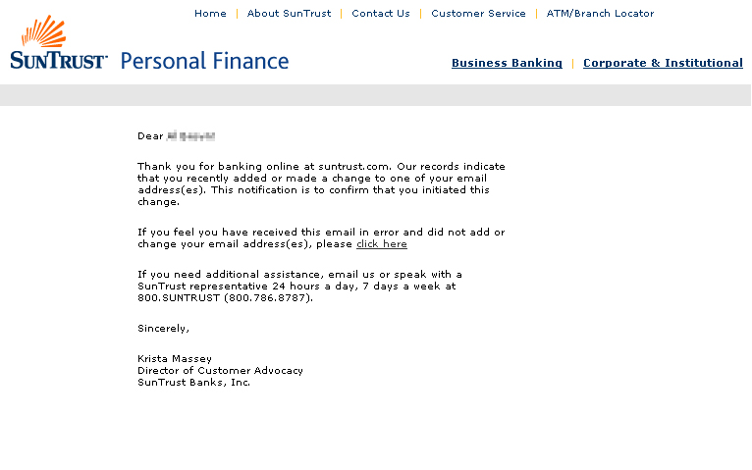

Exhibit B

Example of Phishing Email (seeking login and password):
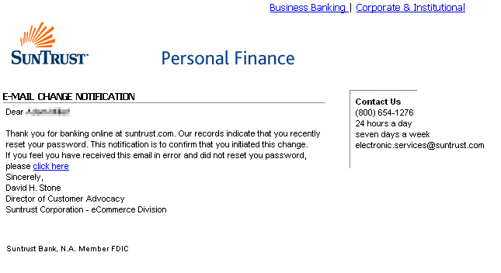

Exhibit C
Actual SunTrust Bank Home Page
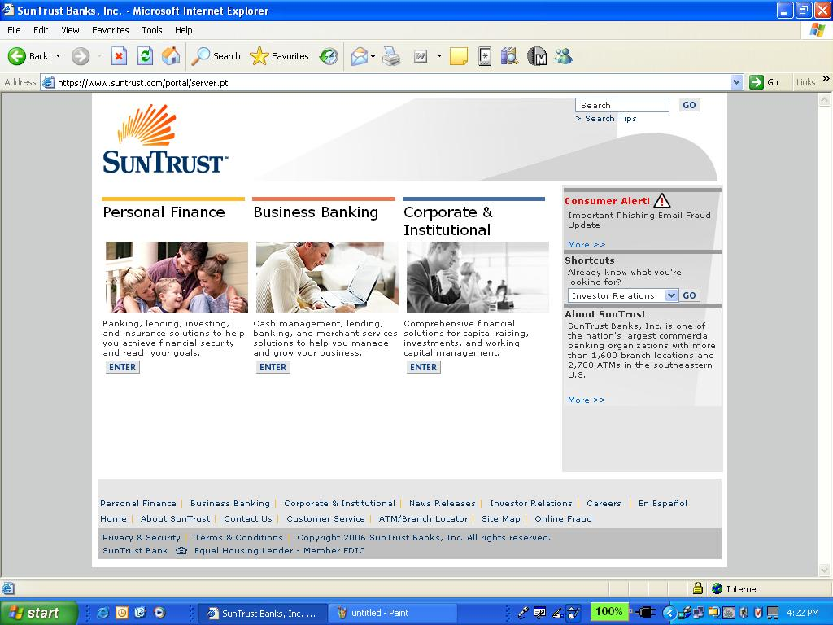

Part I prepared by Jonathan Wilson, Web.com, Inc.
Part II prepared by C. Celeste Creswell and Joseph W. Ozmer, II, Wargo & French LLP.
Symantec Internet Security Threat Report (Volume X, Sept 2006) available at http://www.symantec.com
Id.
Georgia S.B. 394, Section (b).
Id. at Section (e).
Id. at Section (d)(1).
Id. at Section (f).
Id. at Section (i)(1).
Id. at Section (i)(2).
Id. at Section (i)(3).
Ohio H.B. 633 (126th Gen. Sess.) (as introduced).
Id. at Sec. 1349.86(B)(3).
Id. at Sec. 1349.87(A).
No. 05-C-0233-S, 2005 WL 2240952 (W.D. Wis. Sept. 13, 2005). The plaintiff, a Wisconsin-headquartered multibank holding company, accused EarthLink of falsely identifying the bank's web site as "potentially fraudulent" in a warning published by EarthLink's ScamBlocker tool. The court granted summary judgment to EarthLink and dismissed all of the plaintiff’s claims, reasoning the CDA immunized EarthLink from liability for the plaintiff’s Lanham Act, tortious interference with business relations, negligence, and state statutory fraudulent representation claims. The authors of this article represented EarthLink in the Associated Bank litigation.
47 U.S.C. § 230 (footnote omitted).
456 F.3d 1316 (11th Cir. 2006).
Id. at 1320.
Id. at 1322.
Id. at 1322-23.
Id. at 1322.
Id. at 1323-24.
Id. at 1323 & n.4.
340 F. Supp. 2d 1077 (C.D. Cal. 2004).
Almeida, 456 F.3d at 1321 & n.3, 1323.
Id. at 1323.
Id.
418 F. Supp.2d 1142, 1148-49 (D. Ariz. 2005).
No. 06-11888, 2006 WL 2243041 (11th Cir., Aug. 1, 2006).
Id. at *2.
421 F. Supp. 2d 1257 (N.D. Cal. 2006).
R.L. Lackner, Inc. v. Sanchez, No. Civ. A. B-05-264, 2005 WL 3359356 (S.D. Tex. Dec. 9, 2005); Cisneros v. Sanchez, 403 F. Supp. 2d 588 (S.D. Tex. 2005).
422 F. Supp. 2d 523, 536 (D. Md. 2006).
Id.
No. Civ. 05-926-AA, 2005 WL 3005602 (Nov. 8, 2005).
Id. at *4.
Civil Action No. 04-1318, 2006 WL 2506318, at *2-3 (E.D. Pa. Aug. 30, 2006).
Id. at *1.
Id. at *2-6.

